- Installasi
Copas warna hitam
Microsoft Windows [Version 10.0.22631.3958]
(c) Microsoft Corporation. All rights reserved.

C:\Users\MASTER CORE>cd c:\xampp\mysql\bin\

c:\xampp\mysql\bin>mysql -u root
Welcome to the MariaDB monitor. Commands end with ; or \g.
Your MariaDB connection id is 8
Server version: 10.4.32-MariaDB mariadb.org binary distribution

Copyright (c) 2000, 2018, Oracle, MariaDB Corporation Ab and others.

Type 'help;' or '\h' for help. Type '\c' to clear the current input statement.

MariaDB [(none)]>

- Create Database ( mahasiswa )
Ss ke 1
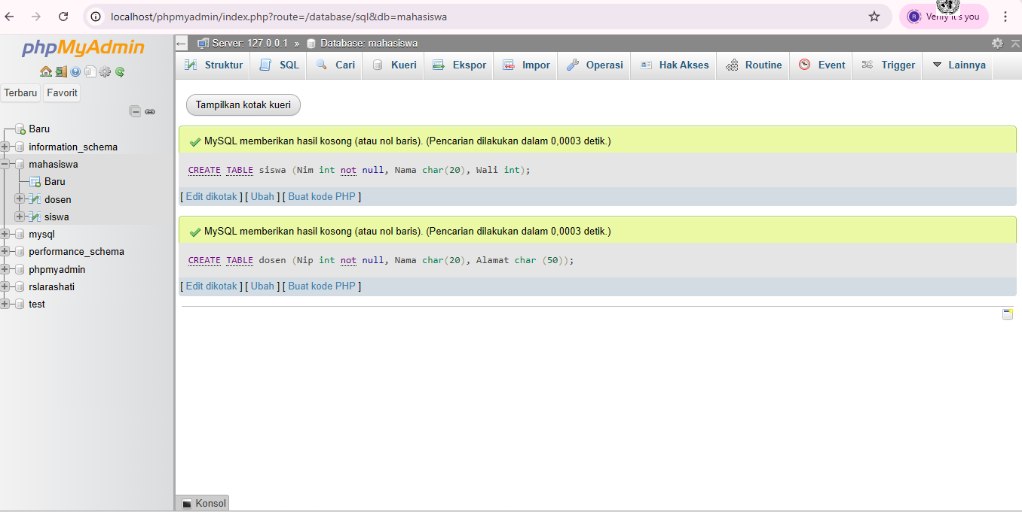

- Insert ( memsukan) data kedalam tabel
- Tabel siswa
Ss ke 2 siswa
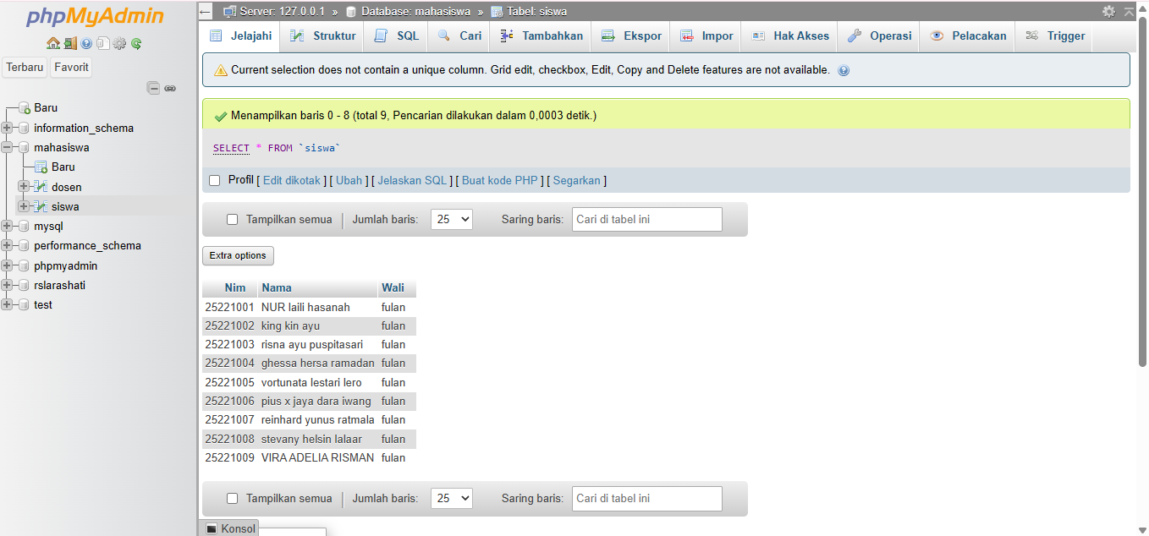
- Tabel dosen
Ss ke 3 dosen
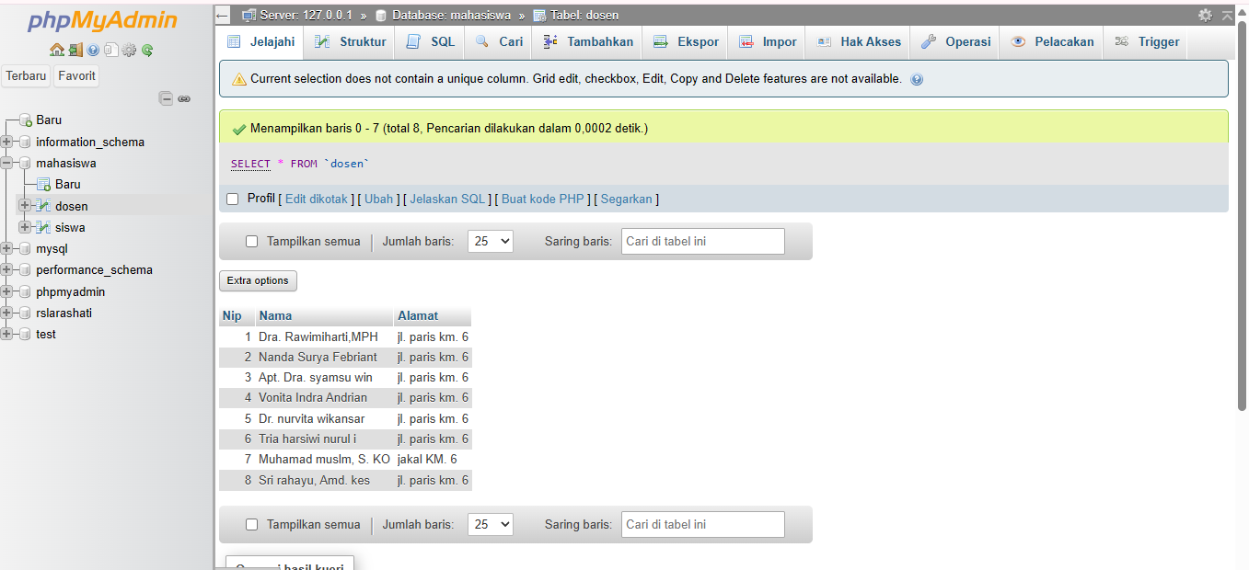
- Select ( menampilkan) data
- SELECT * FROM siswa;
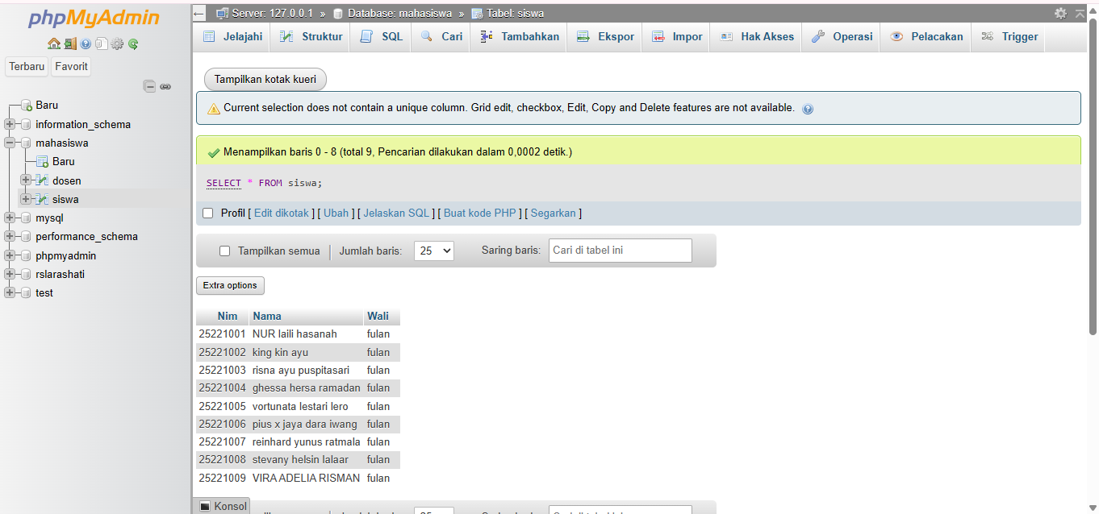
- SELECT * FROM dosen;
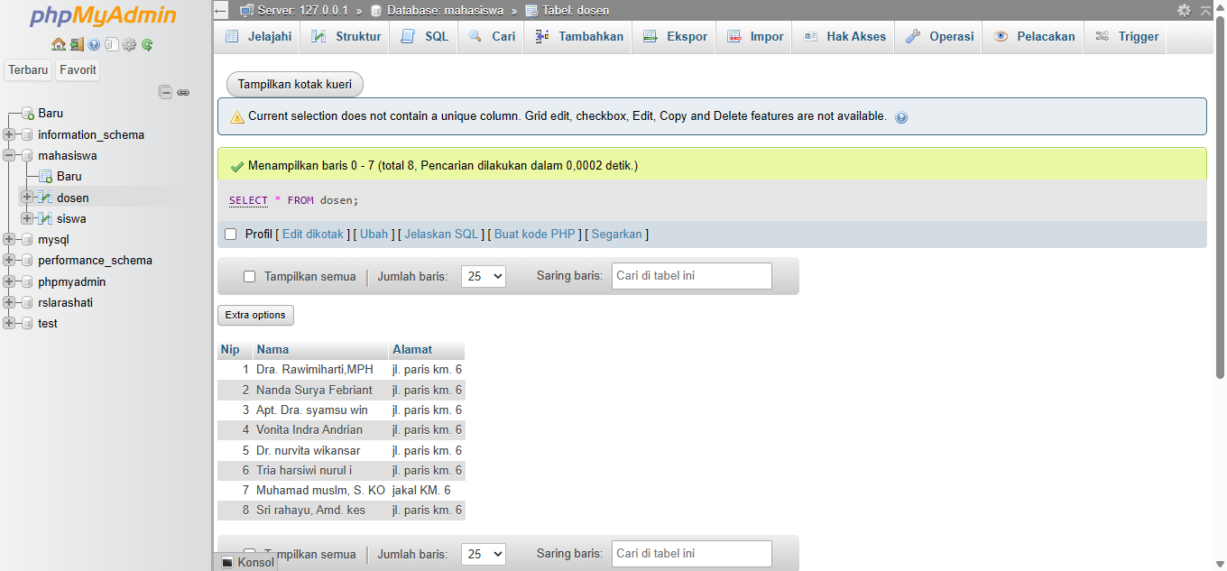
- SELECT nip, nama from dosen;
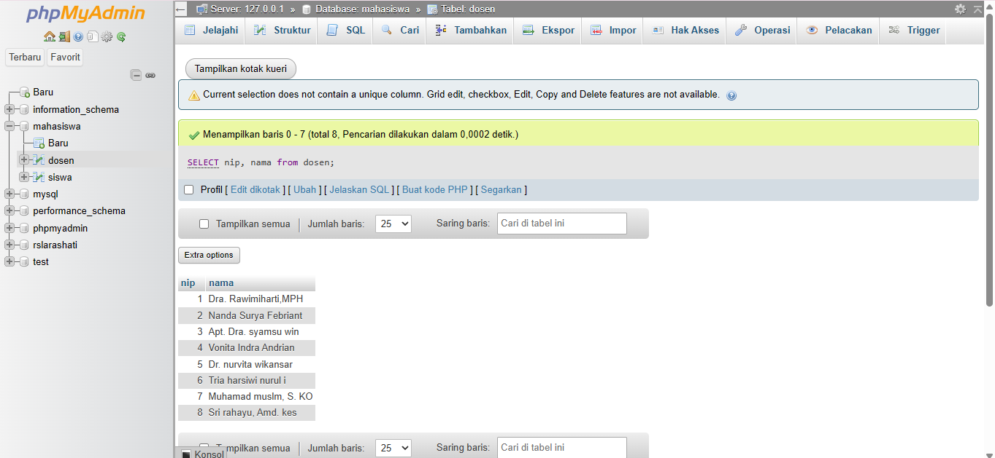
- SELECT * FROM siswa WHERE nim = 25221009;
